CS 499 Module One Assignment Template

Complete this template by replacing the bracketed text with the relevant information.

- Self-Introduction: Address all of the following questions to introduce yourself.

  - How long have you been in the Computer Science program?

I have been in the SNHU computer science program since January, 2024.

  - What have you learned while in the program? List three of the most important concepts or skills you have learned.

I’ve learned so many things from this program! I think that some of the most important concepts I’ve learned are OOP (object oriented programming), Defense In Depth, and the CIA (Confidentiality, Integrity and Accessibility) security triad. I also had a lot of fun learning the basics of cryptography and discrete mathematics!

  - Discuss the specific skills you aim to demonstrate through your enhancements to reach each of the course outcomes.

I would like to demonstrate my core competency with basic coding and my understanding of developing software with a security mindset.

  - How do the specific skills you will demonstrate align with your career plans related to your degree?

I love cybersecurity, so having a good understanding of coding is crucial. It’s important to understand how code works on every level, even though actually developing software is not my professional goal. By showing my understanding of code, I can hopefully prove my competency in parsing code and catching potential bugs or exploitable vulnerabilities.

  - How does this contribute to the specialization you are targeting for your career?

I am actually hoping to someday specialize in both psychology and cybersecurity, I would like to study the effects that early internet exposure can have on developing brains. I would also like to teach someday. The internet is constantly rapidly evolving, and it can be really difficult to know how to stay safe online, especially for more vulnerable individuals. Someday I’d like to teach classes for basic online safety for children, older adults, and/or disabled people. I think that having a good, in-depth understanding of a subject is crucial in order to be able to teach someone else about that subject well.

- ePortfolio Set Up:

  - Submit a screen capture of your ePortfolio GitHub Pages home page that clearly shows your URL.
    - You already have a repository in GitHub where you uploaded projects in previous courses. Your ePortfolio will reside in GitHub but can link to work at other sites, such as Bitbucket.

  - Use the GitHub Pages link in the Resource section for directions on:
    - How to create your GitHub website and publish code to GitHub Pages
    - Issues, such as adding links to other sites

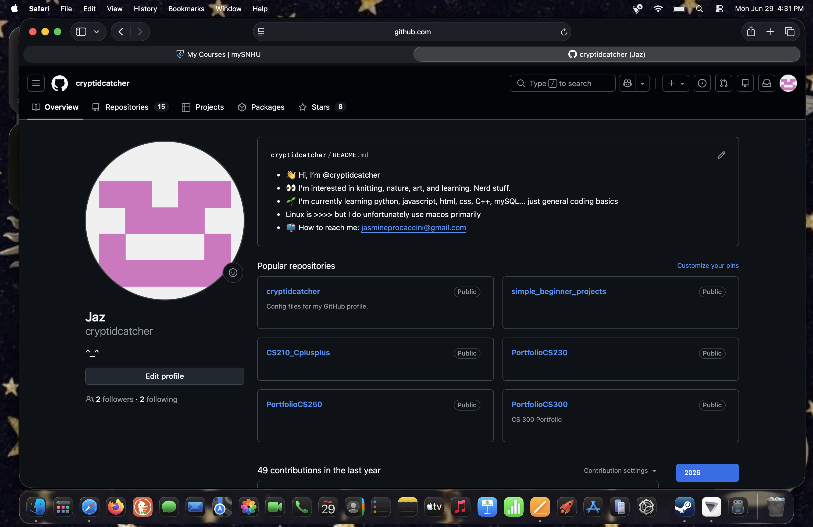
  - Paste a screenshot of your GitHub Pages home page with your URL clearly showing in the space below.
- Enhancement Plan:

  - Category One: Software Engineering and Design
    - Select an artifact that is aligned with the software engineering and design category and explain its origin. Submit a file containing the code for the artifact you choose with your enhancement plan.

CS 330: Computational Graphics and Visualization
https://github.com/cryptidcatcher/CS-330-Portfolio
(A link to the repository. The files that I’ll be looking at are under “7-1_FinalProjectMilestone”)

Note: Your artifact may be work from the following courses:

- IT 145: Foundation in Application Development
- CS 250: Software Development Lifecycle
- CS 260: Data Structures and Algorithms
- IT 315: Object Oriented Analysis and Design
- CS 320: Software Testing, Automation, and Quality Assurance
- CS 330: Computational Graphics and Visualization
- CS 340: Advanced Programming Concepts
- CS 350: Emerging Systems Architectures and Technologies
- CS 360: Mobile Architecture and Programming
- IT 365: Operating Environments
- IT 380: Cybersecurity and Information Assurance
- CS 405: Secure Coding
- CS 410: Reverse Software engineering
- IT 340: Network and Telecommunication Management
- IT 380: Cybersecurity and Information Assurance

    - Describe a practical, well-illustrated plan for enhancement in alignment with the category, including a pseudocode or flowchart that illustrates the planned enhancement.

- Update and complete #readme
- Review MainCode
- Review ShaderManager
- Review SceneManager
- Review ViewManager
- Update all. Check for any redundancies or unnecessary comments.

For this category of enhancement, consider improving a piece of software, transferring a project into a different language, reverse engineering a piece of software for a different operating system, or expanding a project’s complexity. These are just recommendations. Consider being creative and proposing an alternative enhancement to your instructor.

Think about what additions to include to complete the enhancement criteria in this category. Since one example option is to port to a new language, that is the kind of scale that is expected. This does not mean you need to port to a new language but instead have an equivalent scale of enhancement. Underlying expectations of any enhancement include fixing errors, debugging, and cleaning up comments, but these are not enhancements themselves.

    - Explain how the planned enhancement will demonstrate specific skills and align with course outcomes.

      - Identify and describe the specific skills you will demonstrate that align with the course outcome.

I hope to demonstrate my debugging and code editing skills. Also, with his enhancement, I hope to highlight my software design skills.

      - Select one or more of the course outcomes below that your enhancement will align with.

Design, develop, and deliver professional-quality oral, written, and visual communications that are coherent, technically sound, and appropriately adapted to specific audiences and contexts.

Course Outcomes:

- Employ strategies for building collaborative environments that enable diverse audiences to support organizational decision-making in the field of computer science.
- Design, develop, and deliver professional-quality oral, written, and visual communications that are coherent, technically sound, and appropriately adapted to specific audiences and contexts.
- Design and evaluate computing solutions that solve a given problem using algorithmic principles and computer science practices and standards appropriate to its solution while managing the trade-offs involved in design choices.
- Demonstrate an ability to use well-founded and innovative techniques, skills, and tools in computing practices for the purpose of implementing computer solutions that deliver value and accomplish industry-specific goals.
- Develop a security mindset that anticipates adversarial exploits in software architecture and designs to expose potential vulnerabilities, mitigate design flaws, and ensure privacy and enhanced security of data and resources.

  - Category Two: Algorithms and Data Structures

- Select an artifact that is aligned with the algorithms and data structures category and explain its origin. Submit a file containing the code for the artifact you choose with your enhancement plan. You may choose work from the courses listed under Category One.

CS 320: Software Testing, Automation, and Quality Assurance
https://github.com/cryptidcatcher/CS320

- Describe a practical, well-illustrated plan for enhancement in alignment with the category, including a pseudocode or flowchart that illustrates the planned enhancement.

- Review #Readme, update as needed
- Complete any remaining #FixMe’s
- Run automated tests on software to ensure functionality
- Manually review code, look for any apparent vulnerabilities
- Sort the java files into folders
            - “Data” for the data files, “services” for the [data]Service files. Potentially “Test” for the test files, or delete if unnecessary
- Review all classes, see where code can be adapted to be more secure
- Fix JUNIT testing in ContactServiceTest

For this category of enhancement, consider improving the efficiency of a project or expanding the complexity of the use of data structures and algorithms for your artifact. These are just recommendations. Consider being creative and proposing an alternative enhancement to your instructor. Note: You only need to choose one type of enhancement per category.

Think about what additions to include to complete the enhancement criteria in this category. Since one example option is to port to a new language, that is the kind of scale that is expected. Perhaps you might increase the efficiency and time complexity of an algorithm in an application and detail the logic of the increased time complexity. Remember, you do not need to port to a new language but instead have an equivalent scale of enhancement. Underlying expectations of any enhancement include fixing errors, debugging, and cleaning up comments, but these are not enhancements themselves.

- Explain how the planned enhancement will demonstrate specific skills and align with course outcomes.

  - Identify and describe the specific skills you will demonstrate to align with the course outcome.

With this enhancement, I would like to demonstrate my knowledge of software testing and quality assurance by testing the code both manually and dynamically. I also hope to show my understanding of data structures and algorithms.

  - Select one or more of the course outcomes listed under Category One that your enhancement will align with.

Demonstrate an ability to use well-founded and innovative techniques, skills, and tools in computing practices for the purpose of implementing computer solutions that deliver value and accomplish industry-specific goals.

  - Category Three: Databases

    - Select an artifact that is aligned with the databases category and explain its origin. Submit a file containing the code for the artifact you choose with your enhancement plan. You may choose work from the courses listed under Category One.

CS 340: Advanced Programming Concepts
https://github.com/cryptidcatcher/PortfolioCS340

    - Describe a practical, well-illustrated plan for enhancement in alignment with the category, including a pseudocode or flowchart that illustrates the planned enhancement.

- Test core database functionality
              - Test adding items, deleting, and updating
- Test database search functionality
- Test AnimalShelterCRUD functionality
- Remove unnecessary comments from projectTwo.ipnyb

For this category of enhancement, consider adding more advanced concepts of MySQL, incorporating data mining, creating a MongoDB interface with HTML/JavaScript, or building a full stack with a different programming language for your artifact. These are just recommendations; consider being creative and proposing an alternative enhancement to your instructor. Note: You only need to choose one type of enhancement per category.

Think about what additions to include to complete the enhancement criteria in this category. Since one example option is to port to a new language, that is the kind of scale that is expected. Perhaps you might increase the efficiency and time complexity of an algorithm in an application and detail the logic of the increased time complexity. Remember, you do not need to port to a new language but instead have an equivalent scale of enhancement. Underlying expectations of any enhancement include fixing errors, debugging, and cleaning up comments, but these are not enhancements themselves.
    - Explain how the planned enhancement will demonstrate specific skills and align with course outcomes.

      - Identify and describe the specific skills you will demonstrate that align with the course outcome.

I would like to demonstrate my understanding of databases and how to manage them. Also, I hope for this to demonstrate my competency with maintaining a security mindset in my coding.

      - Select one or more of the course outcomes listed under Category One that your enhancement will align with.

Develop a security mindset that anticipates adversarial exploits in software architecture and designs to expose potential vulnerabilities, mitigate design flaws, and ensure privacy and enhanced security of data and resources.

- ePortfolio Overall Skill Set

  - Accurately describe the skill set to be illustrated by the ePortfolio overall.
    - Skills and outcomes planned to be illustrated in the code review

The primary skills which I hope to illustrate with my code review are competency with basic coding in various languages, debugging and editing code. I also hope to demonstrate my understanding of more complex code-related topics like database structures and adapting algorithms to improve them.

    - Skills and outcomes planned to be illustrated in the narratives

I hope to demonstrate my growth over the course of my studies! I think that my skills and understanding of computer science and cybersecurity have improved significantly through my studies at SNHU and I hope to demonstrate that growth through this capstone.

    - Skills and outcomes planned to be illustrated in the professional self-assessment

I hope to show my ability to follow written instructions and explain code in non-technical terms that can be easily understood by a broad audience. I also hope to demonstrate appropriate self-reflection and growth as a computer scientist.

